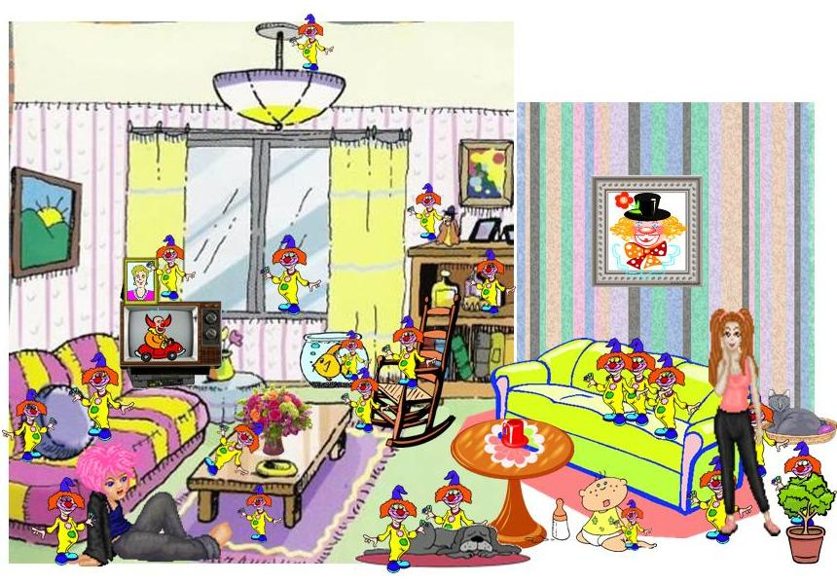


Look at the picture and find as many clowns as you can.
How many did you find: ____
Complete the sentences with the correct preposition.
in, on, in front, of, behind, next to, between

1. There is a clown _________ the dog and another one __________ the dog.
2. There is a clown ___________ the window-sill.
3. There is a clown _____________ the plant.
4. There is a clown ________ the sofa.
5. There is a clown _______ the rocking chair and another one ____ it.
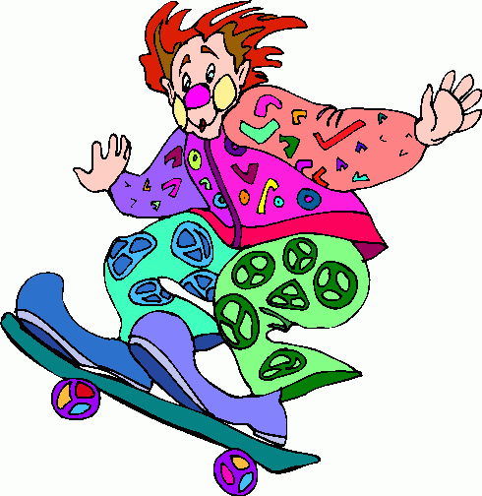
6. There is a clown _________ the table.
7. There is a clown ________ near picture on the TV.
8. There is a clown ___________ the picture which is on the wall.
9. There is a clown ________ the shelf.
10. There is a clown __________ the sitting girl.
11. There is a clown __________ the baby.
12. There is a clown ________ the flower vase.
13. There is a clown _________ the carpet.
14. There is a clown ____________ the lamp.

